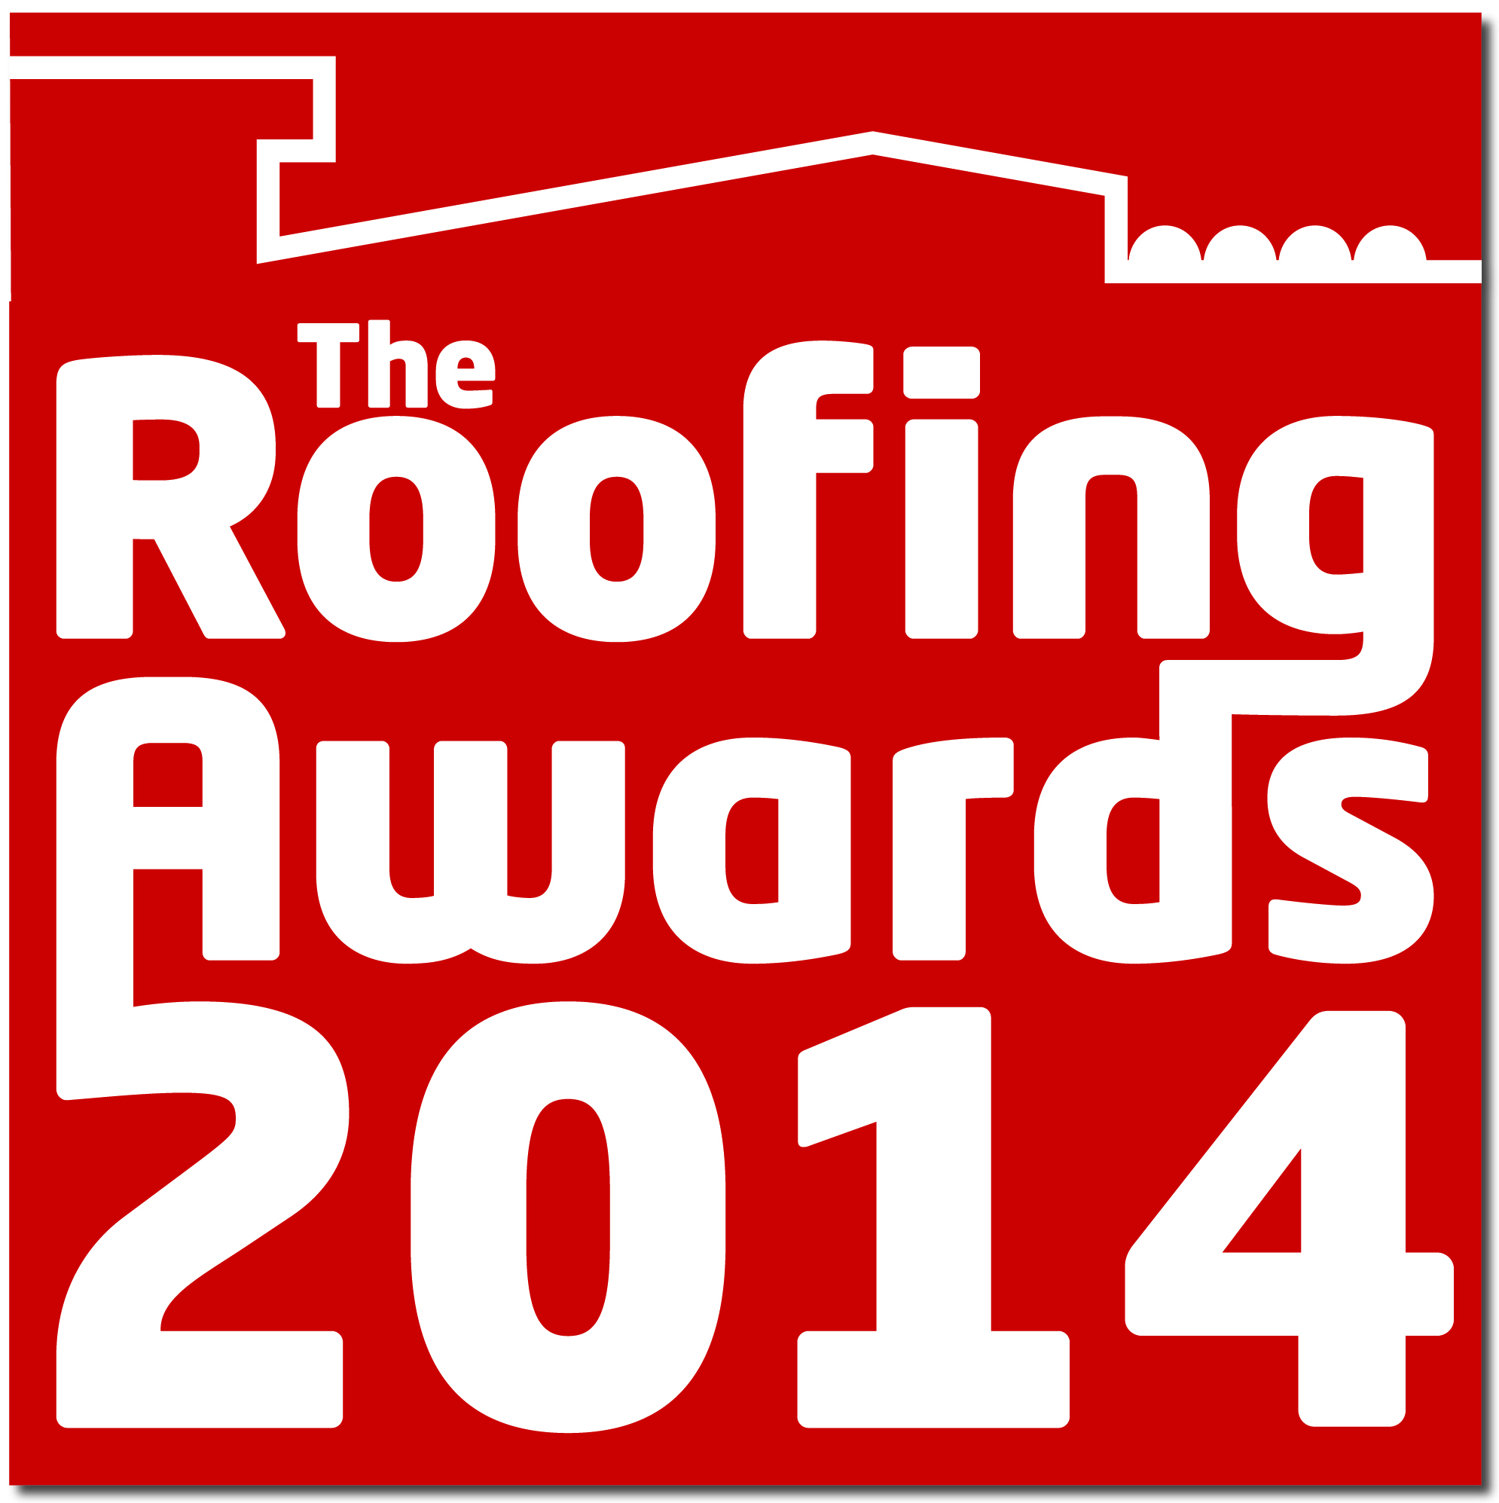

APPLICATION FORM

Hosts:

LRWA
SPRA
LCA
LSA
RTA
CompetentRoofer
NFRC
Green Roof Centre
MCRMA
FTMRC
Introduction:

The Roofing Awards – a highlight of the industry’s year – recognise and reward outstanding standards of workmanship and safety among competent roofing companies. Judging will be undertaken by a panel of independent professionals. The winners will be announced at the Roofing Awards Congress on Friday 16th May 2014 at the Hilton London Metropole.

Rules of entry:

- The Roofing Awards are free to enter.
- Entries must be received no later than Friday 24th January 2014. Late entries will not be accepted.
- All entries should be for a project with a completion date between 1st December 2012 and 31st December 2013. When the project started is not important.
- You may enter more than one project but each one must be accompanied by a separate entry form.
- Please only enter each project into one category.
- The entries are judged by a panel of independent construction professionals with guidance from trade association experts. The short-listing and judging will take place in February 2014. The decision of the short-listing experts and the judges is final and no further correspondence will be entered into.
- Manufacturers entering projects must ensure that the roofing contractor is a member of one of the Roofing Awards supporting trade associations, as listed on the front of the application form.

How to enter:

- Entries will be accepted electronically or in the post but this application form must be completed in full for each project.
- You may submit supporting material but this must be saved in a suitable file format (Word, PDF, JPEG or TIFF).
- The quality of photographs is vital to the success of your entry. Please provide a good selection of high resolution photos – before, after and work in progress, including close-up and detailed shots of the roof.
- The photographs should be checked by the company safety officer to ensure compliance with any relevant Health & Safety Regulations (e.g. correct PPE).
- Photographs must be electronic – minimum resolution 300dpi – (either emailed, file transfer, USB or CD) for the entry to progress. Unless specifically requested, USB sticks and CDs will not be returned.
- Particular consideration is given for special initiatives, and for the challenges that were resolved in the duration of the project. Please see the criteria overleaf for more information.
- Keep the information concise and relevant; we will ask for more information if we need it.

Send your entry:
By post:
Debbie Simcock, Roofing Awards, Roofing House, 31 Worship Street, London EC2A 2DY

By email:
debbie@nfrc.co.uk

Enquiries: 0207 638 7663

We want members to have the best chance of winning and following feedback from entrants in previous years, we have compiled a list for you to consider on submitting your entry. Each project and discipline is different so not every heading will apply to every project. However, the judges will take the following into consideration:

- Degree of difficulty
  - Complexity and/or unusual nature of details
- Aesthetics
  - Visual impact
  - Appearance
  - Finish
- Problem-solving
  - Coping with time/space/ other constraints
  - Innovative solutions
  - Completion of non-standard details
  - Special requirements from main contractor, homeowner or others
- Customer satisfaction
  - Extracts from client letters
  - Professional endorsements
- Health & Safety performance
  - Appropriate hierarchy of fall protection
  - Correct use of PPE and RPE
  - Safe use of ladders and access platforms
  - Safe use of tools and equipment
  - Safe movement on and around the roof area (without damaging the roof covering)
- Workmanship
  - Hand skills
  - Attention to detail
  - Demonstration of best practice
- Completion on time/ early and to budget
  - Quality management systems demonstrated
  - Efficient use of labour and materials
  - Enabling others (e.g. other trades/ end users)
- Supply chain best practice, relationship with main contractors etc
  - Demonstration of good project management and planning
  - Working with others
  - Efficient hand-over process
- Contribution to the built environment
  - Value to the community and local area
  - Value to the region or of national importance
  - Restoration of conservation of at risk buildings
- Good workforce culture
  - Training and development
  - Qualifying the workforce/ lifelong learning
  - Mentoring of younger operatives
- Environmental qualities
  - Conservation of heat/power
  - Use of natural light
  - ‘Green’ materials
  - Reclaimed or locally-sourced materials

Please complete the following fields in full:

Contact Name:

Company Name (entering the project):

Roofing Contractor (if different to above):

Trade Association roofing contractor is registered with:

Address:

Postcode:

Email:

Tel/ Mobile:

Please enter this project for ONE category only

Categories:

Pitched:
Roof Slating
Roof Tiling
Heritage Roofing

Metal:
Roof Sheeting
Vertical Cladding/ Rainscreen
Fully supported Metal Roofing (lead/copper/zinc)

Flat:
Reinforced Bituminous Membrane
Single Ply
Liquid Applied Waterproofing
Mastic Asphalt
Project Name:

Project Location (inc. town/city/postcode):

Sustainability:
Solar
Green (vegetated) Roof
Shingles/ Shakes

Depending on the entries received, it may be necessary to merge, sub-divide or delete some of the above categories.
Please complete this form when submitting your entry.

Project Description (include type of building, what work needed to be done):

Main Covering (please list manufacturer/supplier if known and type):

Other materials (please list manufacturer/supplier if known and type):

Fixings and generic materials (if applicable) and supplier:

Please explain more about the project and in particular your reasons for entering it
(e.g. challenges, high skill areas, environmental factors, conservation issues, unusual details, outstanding work by apprentices etc):
This should be a minimum of 200 words.

Continued…

Additional Information: (Optional) Use this page if you need more space or if there is something that does not fit into one of the earlier boxes that is relevant to the project.

For office use only:

Company Name:

Roofing contractor:

Telephone number:

Category:

Trade Association:

Notes:

