Conquering roofing complexity at Lymington Shores

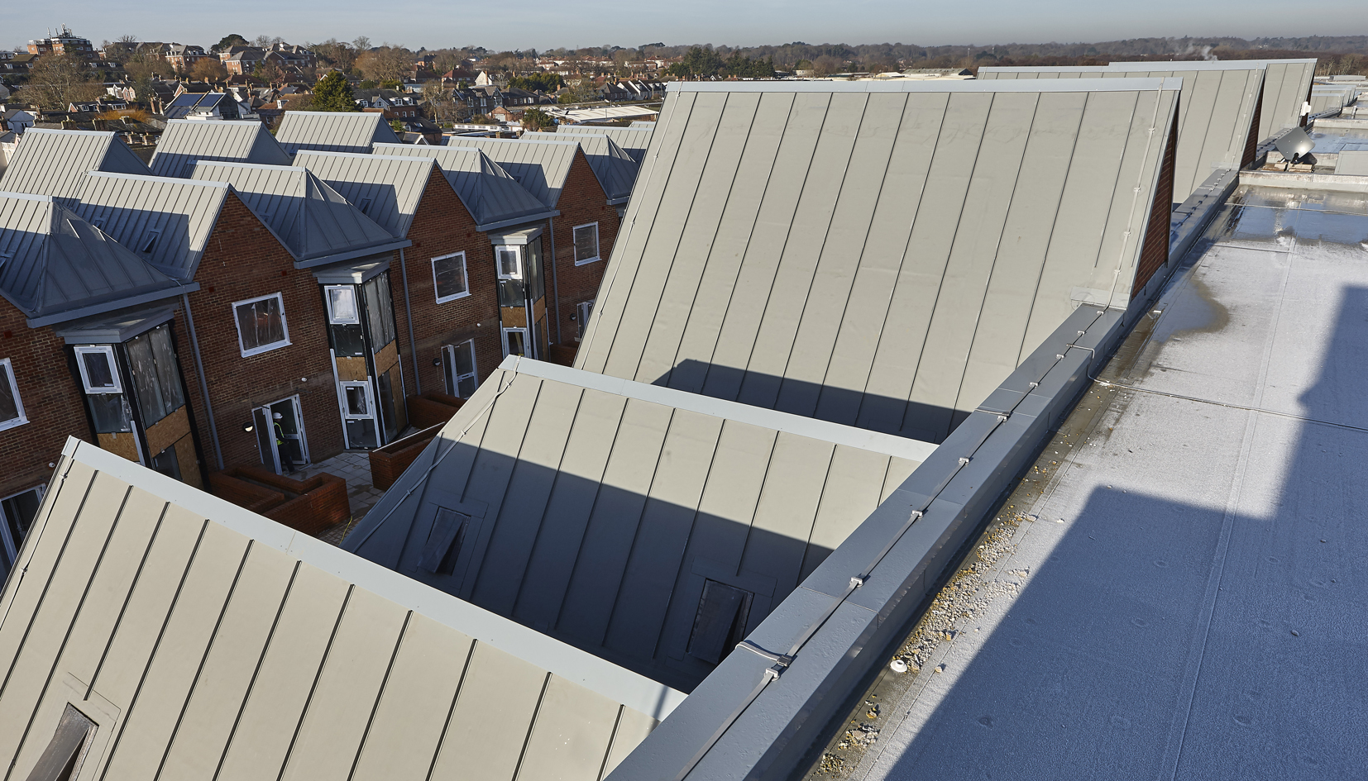

Supplied by SIG Design & Technology, FDT’s Rhepanol fk membrane system was selected to meet Redrow’s requirements on sustainable choices of roofing materials.

**Project:** Lymington Shores Housing Development

**Developer:** [Redrow](https://www.redrow.co.uk/)

**Architects:** APP

**Roofing contractors:** [Flat Roofing Membranes Ltd](http://www.roof.org.uk/)

**Waterproofing membrane:** Rhepanol fk PIB single ply in RAL 7000

Lymington Shores, located just off Hampshire’s Lymington Marina, is a high-end Redrow residential development which required a complex series of multiple single-ply roof specifications to its 12 villas and three apartment blocks of penthouses and duplexes.

Its prestigious location provides fine views of the River Lymington and beyond, and the housing complex is adjacent to the town’s railway station.

The architectural J42 specification included an   
intricate array of roof designs with 164 roof areas, high-impact aesthetics, sustainable membranes and high-quality workmanship.

With the large scale of the project spanning a total of 11,931m2, meeting programme schedules for the following trades was demanding. Flat Roofing Membranes worked closely with appointed architects, and SIG Design & Technology to develop the roof design, specification and all detailing.

Supplied by SIG Design & Technology, FDT’s Rhepanol fk membrane system was selected to meet Redrow’s requirements on sustainable choices of roofing materials. Rhepanol PIB is made from Polyisobutylene (PIB), a synthetic rubber, and is the only membrane currently available with a full Life Cycle Assessment that meets DIN EN ISO 14040-part ff, which demonstrates that it has no significant environmental impact at any time between its manufacture and eventual disposal.

In principle, Rhepanol fk is relatively easy to install, as it has a factory-manufactured, self-sealing edge, but the highest standards of workmanship were nonetheless required on this prestige housing development.

**Four differing specifications over 12,000m2 of   
roof area**

There were four different specifications of roof areas within the overall project. Flat roofed areas measuring 3,371m2 were waterproofed using FDT’s Rhepanol fk RAL 7000 2.5mm thick single ply membrane bonded using adhesive, 170mm uniform thickness Insulation, (in two layers), mechanically fixed, with three fixings per square metre into a base layer of insulation.

There were six fixings per square metre in the top layer of insulation using thermally broken telescopic washers & fixings. The polyethylene vapour control layer was laid-loose over a 18mm thick plywood, to falls, on the roof deck.

The intricate build up to the 3230m2 of pitched roofs with standing seam finish comprised Rhepanol fk RAL 7000 2.5mm thick single ply membrane fully bonded using adhesive. Standing seams were welded to the field sheet at 500mm intervals in a bespoke design by Flat Roofing Membranes Ltd – to replicate lead ‘Birds Beak’ style ventilation units. This was installed over 18mm thick plywood, fixed at varying roof pitches, but generally 45 degrees, to the roof deck.

The third area measuring 1196m2 comprised a cold flat roof build up to bin stores and valley gutters which were insulated in the loft space. Rhepanol fk RAL 7000 2.5mm thick single ply membrane was bonded using adhesive to 18mm thick plywood, to falls, over the   
roof deck.

The 2150m2 of terraced areas were covered in a fleece protection layer, laid loose under Rhepanol fk RAL 7000 2.5mm thick single ply membrane which was bonded using adhesive. Other build up elements comprised 140mm uniform thickness Recticel Powerdeck F bonded using PU adhesive, a bituminous vapour control layer bonded by torching and a bituminous primer which was roller applied. The areas were screeded to falls to the concrete roof deck.

In addition, there are 12 separate villas with a total membrane area of 1984m2. The villas were waterproofed using a combination of the   
specifications above.

During SIG Design & Technology’s regular inspections, compliance to meet the J42 specification, Building Regulations, manufacturer’s product guidance and other standards were monitored continually. Only operatives trained in the installation of Rhepanol fk were and are permitted to install FDT’s membranes.

**Excellence in workmanship**

Delivery of the work was achieved to exacting standards, with the Lymington Shores project being a finalist in the 2017 Roofing Awards Flat Roofing Membrane Single Ply category.

The four distinct types of roof areas demanded that   
the installation team call on all their knowledge, skills and experience.

The pitched roof areas presented the greatest level of technical difficulty to the installers. Visible from every angle, “perfect” execution of both field area and standing seam detailing was required to meet both regulations and ensure aesthetics affecting all 71 roofs.

All standing seams needed to run exactly as per the design criteria, with the objective of perfectly replicating a standing seam metal roof finish. This was successfully achieved.

Part-way through the project, the manufacturers changed the design of the standing seam profile. This prompted negotiations from SIG to continue to supply a specific linear meterage of profiles bespoke to the original design.

The scale and scope of this project meant that an oversized insulation board was specified for speed of installation and to reduce wastage. Coordination of quantities, careful timing and scheduling of deliveries were critical ensure continuity of work on site. The project was completed in February 2017.

MD of roofing contractor Flat Roofing Membranes, Julian Rodgers said: “In the whole of my 30-year   
career in flat roofing, I’ve never worked on a   
project as challenging as this in terms of scope, scale and complexity.

“The project far exceeds the typical flat roofing application and it has given us the opportunity to utilise our expert workmanship to the full in terms of fulfilling both functional and aesthetic demands over what has been a four-year long programme.”

SIG Design & Technology’s trading director, Mike Crook, said: “As sole UK distributor of FDT membranes, I believe this to be probably the most complex project with high impact finished aesthetics that we have seen undertaken using Rhepanol fk.”

Overall, the roofing contractors and SIG delivered at every level on a large yet intricate project that demanded strong workmanship, adherence to stringent standards, rigid project management – and the need to achieve a pleasing aesthetic finish.

**More information**

* Visit the Rhepanol product pages and downloads <http://www.singleply.co.uk/flat-roofs/fdt-rhepanol-pib/>
* Learn more about the 8 steps to the #PerfectRoof [www.singleply.co.uk/perfectroof/](http://www.singleply.co.uk/perfectroof/)
* To find out more about Rhepanol call SIG Design & Technology on 01509 505714 or visit [www.singleply.co.uk](http://www.singleply.co.uk)

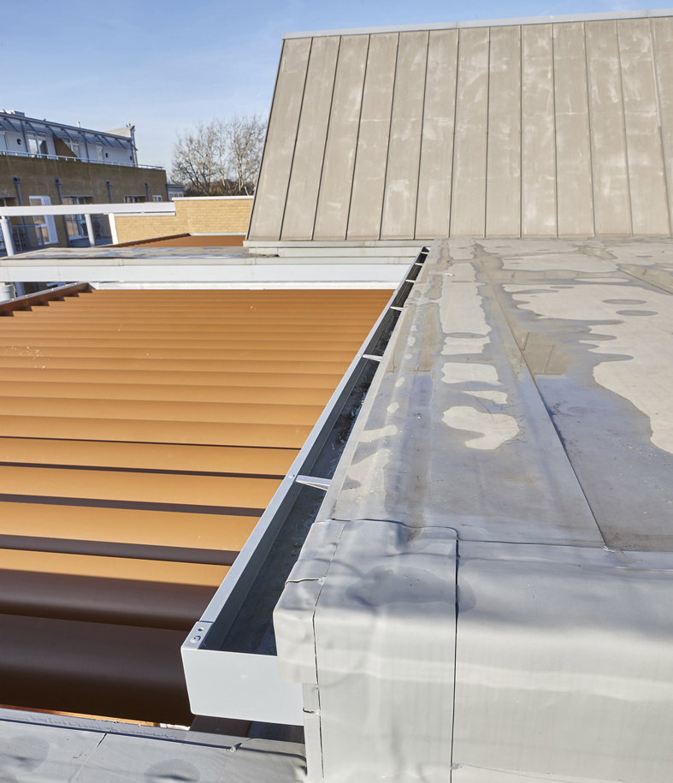

With the project spanning a total of 11,931m2, the overall scale of the project was large and meeting programme schedules for the following trades demanding.

Conquering roofing complexity at Lymington Shores

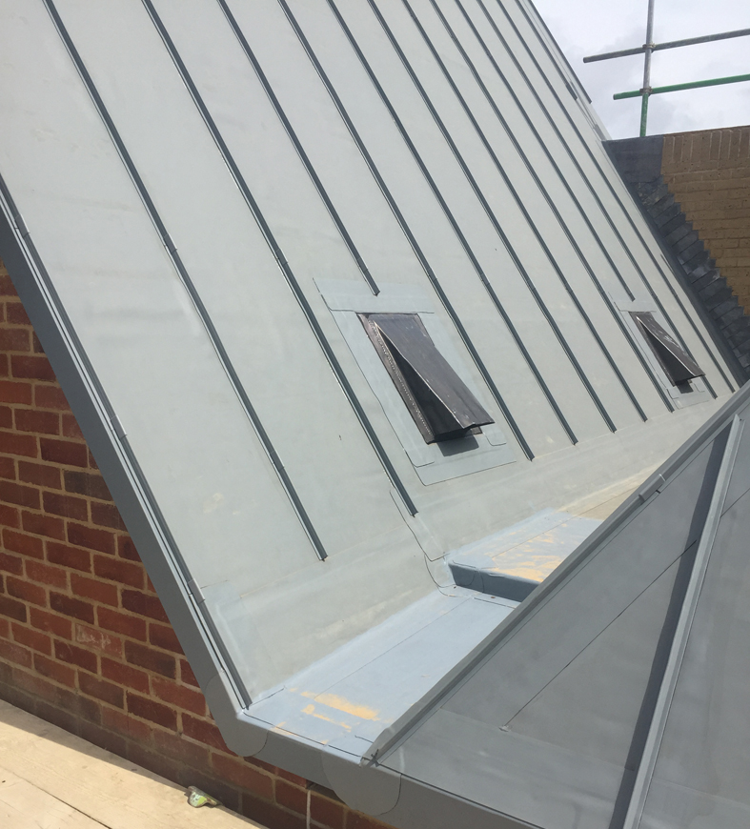

Four distinct types of roof areas demanded that the installation team drew upon all their knowledge skills and experience.

Conquering roofing complexity at Lymington Shores

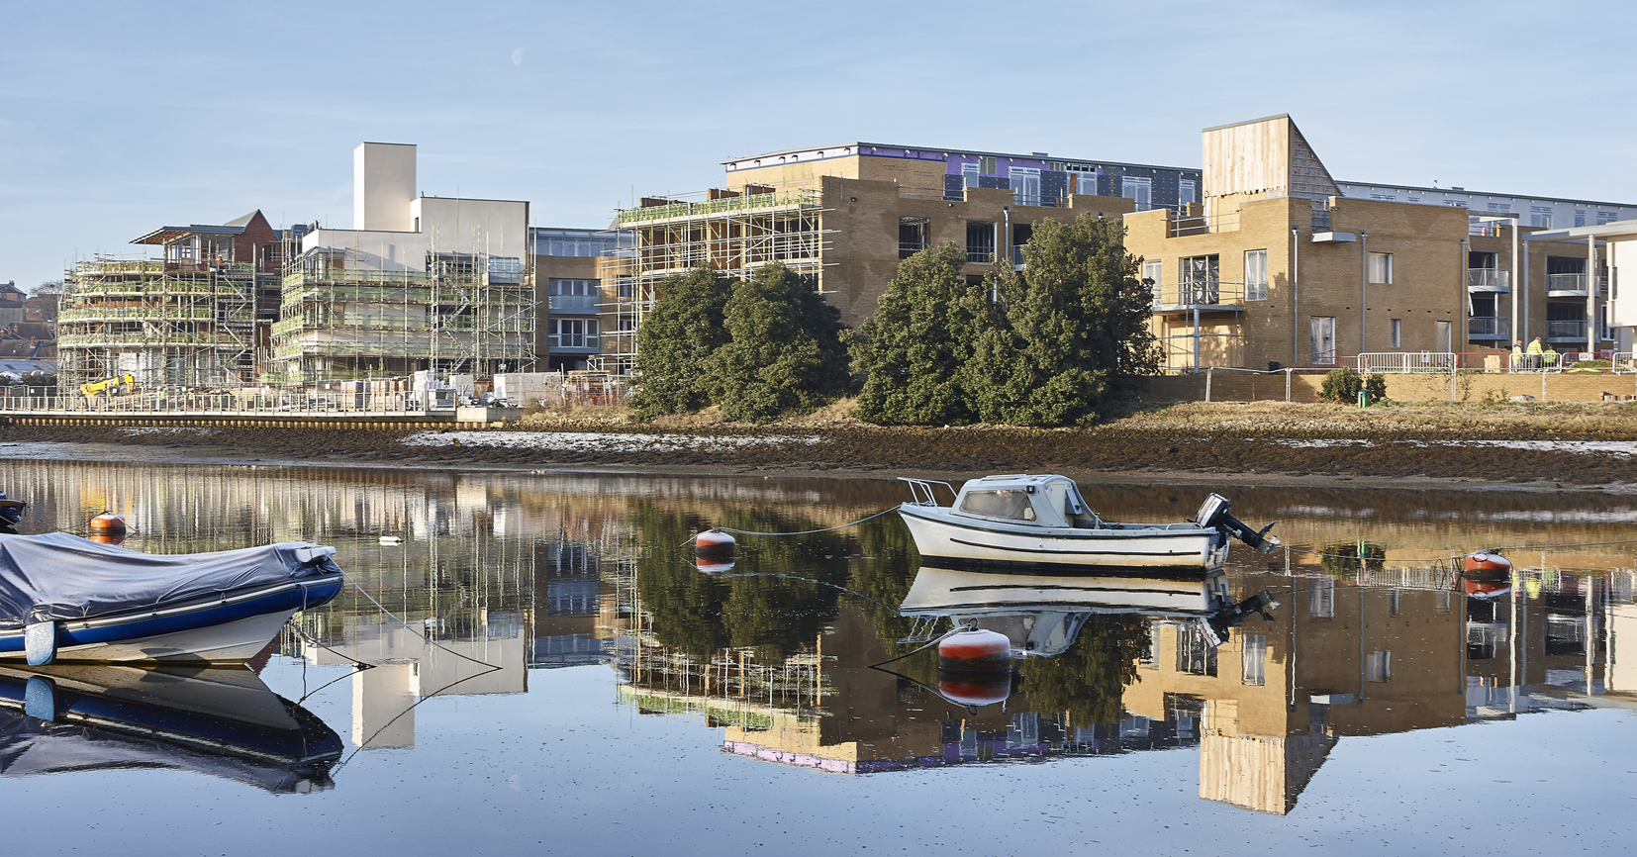

Conquering roofing complexity at Lymington Shores